**WEDDING DECORS**

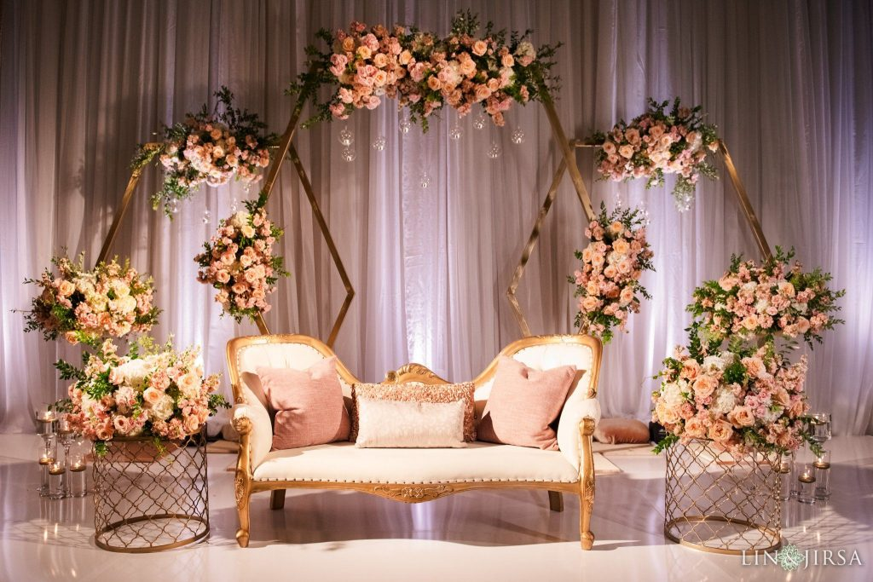

Floral decorations for anniversaries are a poignant expression of love, appreciation, and celebration. Each arrangement is meticulously crafted to honor the couple's journey together, marking another year of shared memories, laughter, and growth. These floral displays serve as both a visual feast and an emotional touchstone, evoking the romance and significance of the occasion.

The selection of flowers is a deeply personal aspect of anniversary floral decoration. Couples may choose blooms that hold special meaning, such as those from their wedding day or varieties that represent significant moments in their relationship. Roses, symbolizing love and passion, are a perennial favorite, while other blooms like lilies, orchids, and peonies add elegance and grace to the arrangements.